**Packet Status :**

1. 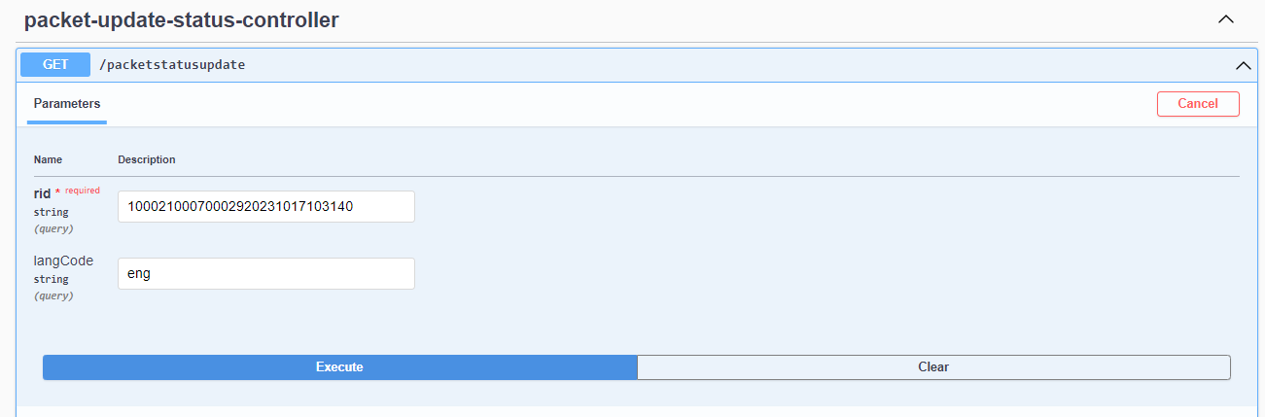Packet status request.

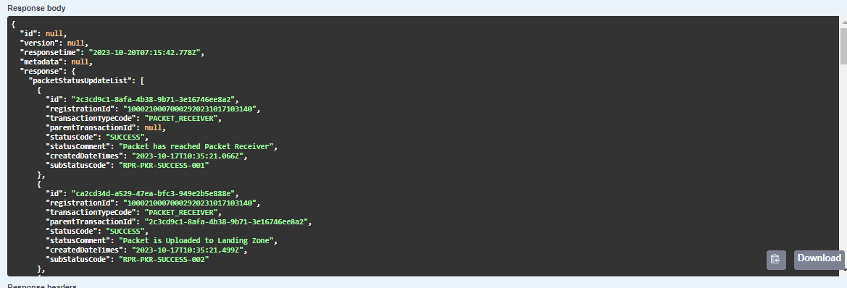packet status: